# Orange HRM

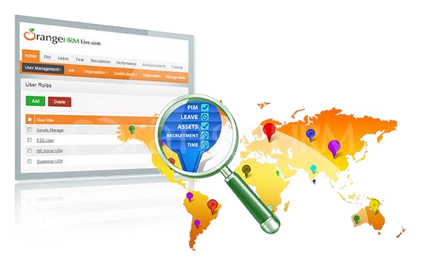

# Project Overview

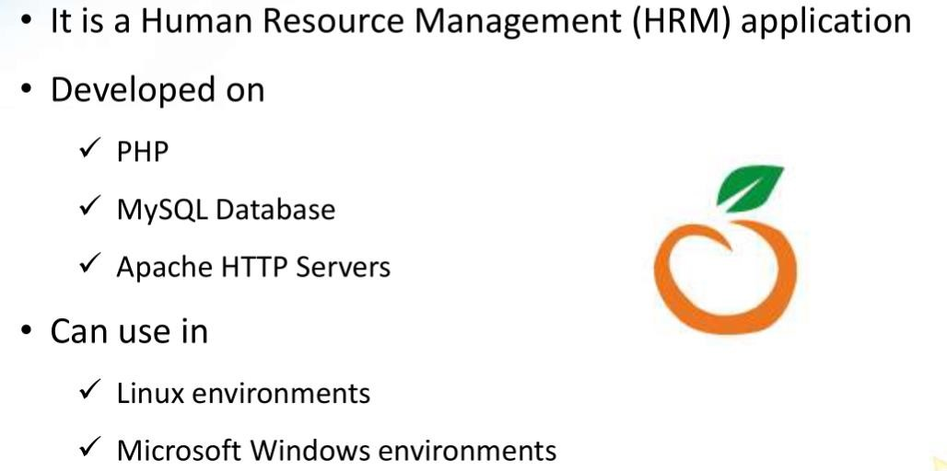

# Admin Module

* Listing Employees/users
* Adding Employees
* Configure Leaves
* Time Sheets
* Recruitment
* Performance of Employees

# ESS Module

* Leaves (Apply, Entitlements etc..)
* Filling Time sheets
* My Info - maintaining personal details
* Performance tracking

# HRM



HRM Admin

Admin

PIM

Leave

Time

Recruitment

Performance



PIM

Leave

Time

My Info

Performance



ESS User

